Data Mining HW1

NE6101034 柳譯筑

**About Dataset**: <https://www.kaggle.com/irfanasrullah/groceries/activity>

我用的dataset 是從kaggle上找的groceries dataset

這個dataset包含了9835 transaction跟169 unique items

**程式架構：**

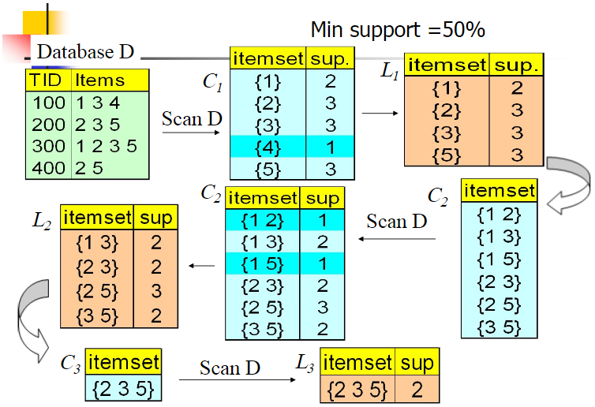

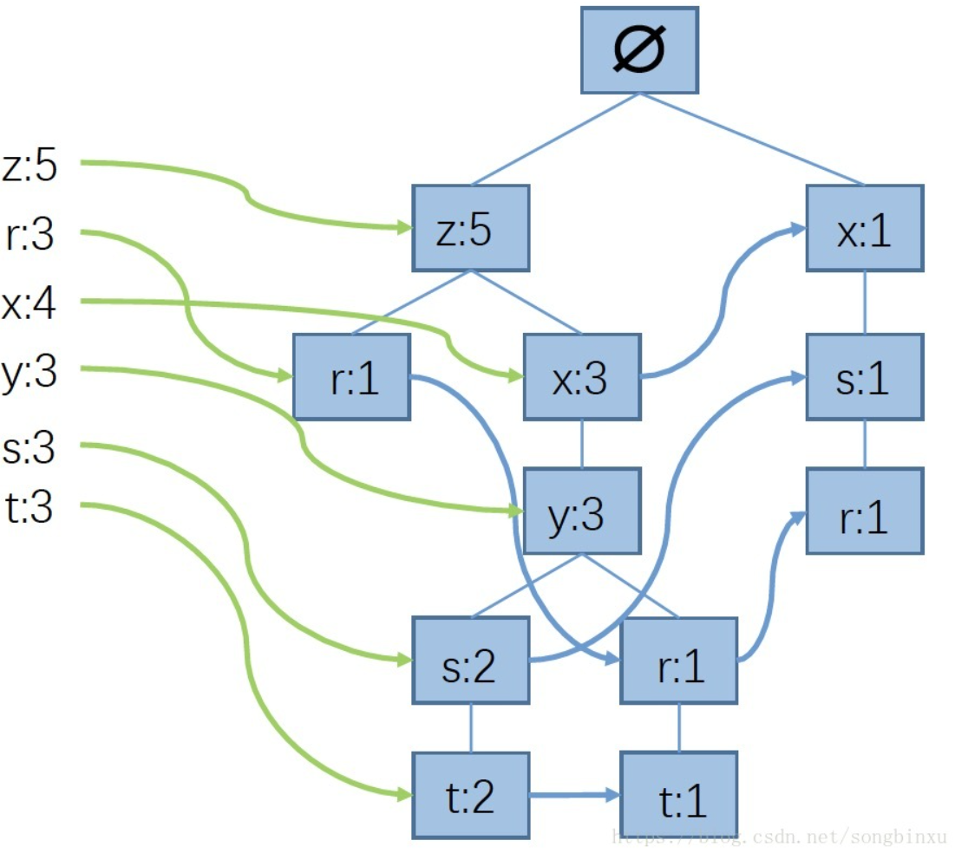

實驗結果

1. **Apriori with brute-force :**

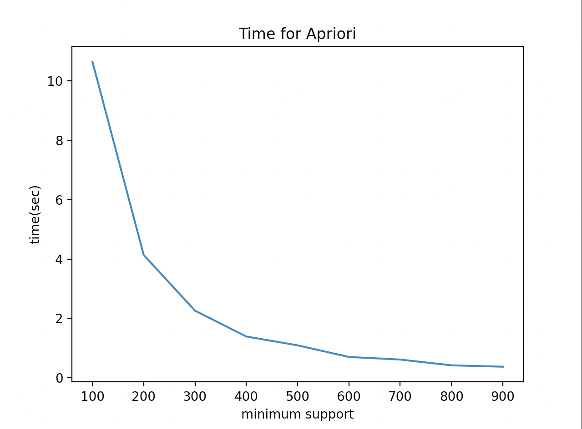

1. **FP Growth:**

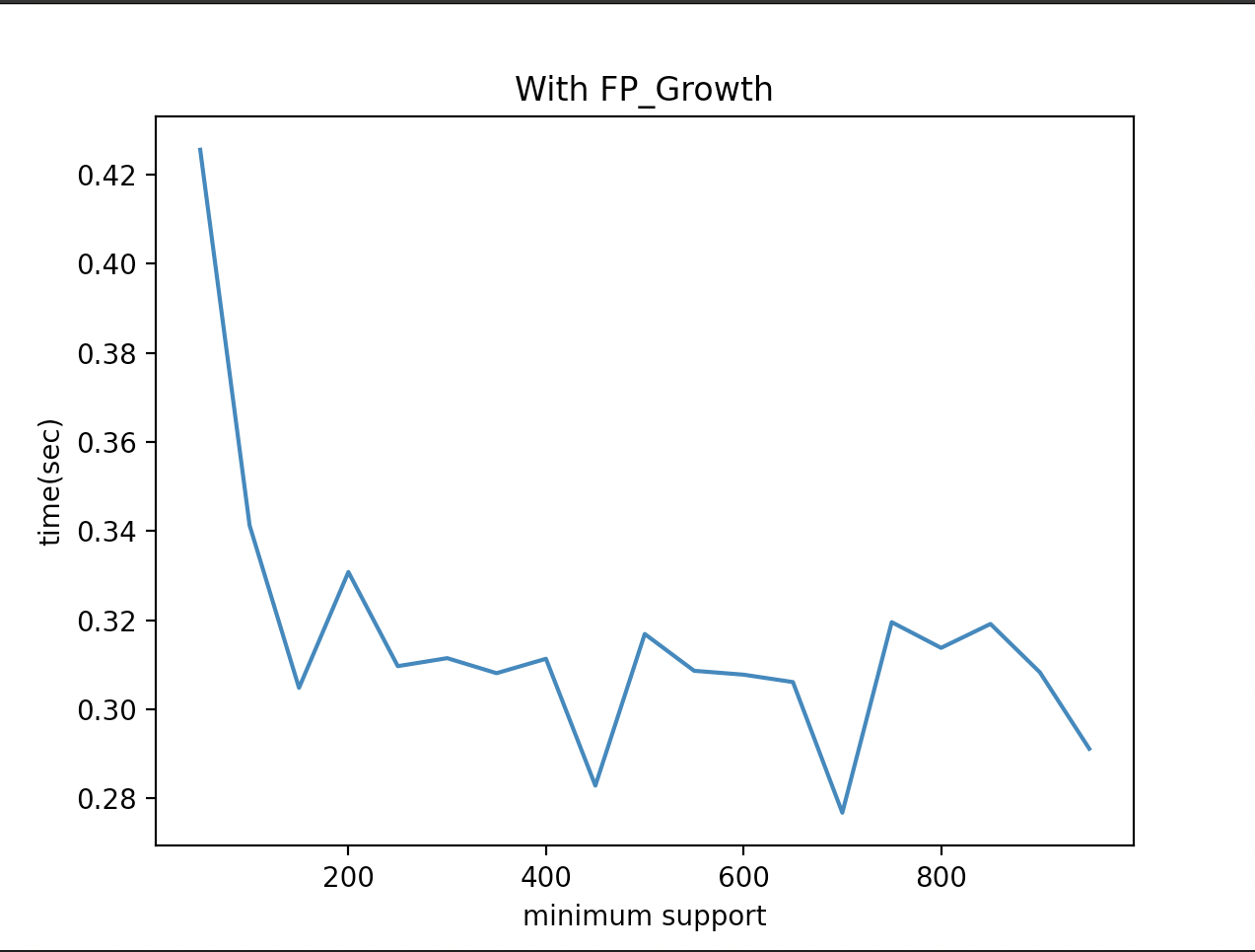

**分析**

**Rule generation** with -

High support, high confidence

High support, low confidence

Low support, low confidence

Low support, high confidence

Total Time: 0.3705322742462158 sec

minsup 900

minconf 0.1

num: 0

Total Time: 0.6789960861206055 sec

minsup 600

minconf 0.1

num: 2

Total Time: 0.685157299041748 sec

minsup 600

minconf 0.2

num: 2

Total Time: 0.6842069625854492 sec

minsup 600

minconf 0.3

num: 1

Total Time: 0.6856534481048584 sec

minsup 600

minconf 0.4

num: 0

Total Time: 1.0889663696289062 sec

minsup 500

minconf 0.1

num: 6

Total Time: 1.0724871158599854 sec

minsup 500

minconf 0.5

num: 0

Total Time: 1.3605141639709473 sec

minsup 400

minconf 0.1

num: 16

Total Time: 1.3487548828125 sec

minsup 400

minconf 0.2

num: 14

Total Time: 1.360137939453125 sec

minsup 400

minconf 0.3

num: 7

Total Time: 1.355186939239502 sec

minsup 400

minconf 0.4

num: 4

Total Time: 1.3585259914398193 sec

minsup 400

minconf 0.5

num: 0

Total Time: 2.2040810585021973 sec

minsup 300

minconf 0.1

num: 36

Total Time: 2.2045092582702637 sec

minsup 300

minconf 0.2

num: 24

Total Time: 2.204713821411133 sec

minsup 300

minconf 0.3

num: 13

Total Time: 2.1939971446990967 sec

minsup 300

minconf 0.4

num: 5

Total Time: 2.195888042449951 sec

minsup 300

minconf 0.5

num: 0

Total Time: 4.035916805267334 sec

minsup 200

minconf 0.1

num: 122

Total Time: 4.0237650871276855 sec

minsup 200

minconf 0.2

num: 72

Total Time: 4.022386789321899 sec

minsup 200

minconf 0.3

num: 36

Total Time: 4.027678966522217 sec

minsup 200

minconf 0.4

num: 15

Total Time: 4.044141054153442 sec

minsup 200

minconf 0.5

num: 1